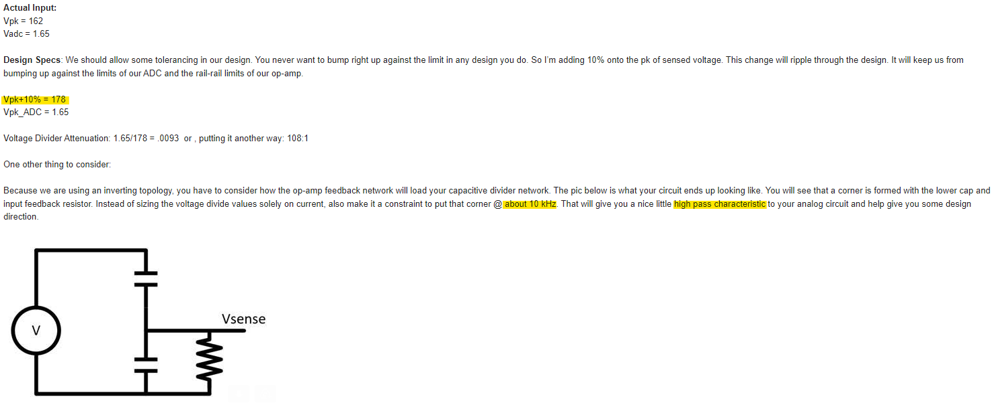

**Parameters**

$V_{peak}=162V±10\%$

$V_{peak}+Attentuation≈178V$

$ADC Range: 0V to 3.3V$

$V_{peak-to-peak}=356V$

**Calculation of HPF @10kHz**

Using 10k Ohm for input feedback resistor

<https://www.electronics-tutorials.ws/filter/filter_3.html>

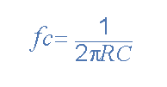

**Solving for $C_{1}$**

$\frac{3.3}{356}=0.009269662921$

$v_{2}=v_{in}\frac{C_{1}}{C_{1}+C_{2}} =>3.3=(356)\frac{C_{1}}{C_{1}+ 1.59*10^{-9}} =>C_{1}=1.48954*10^{-11} =14.9pF$

**Calculation of LPF @2.5MHz**

R = 10k Ohms

<https://www.electronics-tutorials.ws/filter/filter_2.html>

